| **Project – External Documentation** |  |
| --- | --- |
| MOBI6026001  Mobile Cloud Computing |
| <Odd> Semester Year <2023/2024> |

* **Project Title**

Flokemon



* **Introduction**

Flokemon is a store application that offers users a diverse range of *Pokemon* species for purchase, where also its data has been stored in the specific database of flokemon. Users can login with an existing account or using Google Auth for those without an account, registration options are available through Gmail or Google Auth. Users that registered their account using gmail can personalize their experience by updating their profiles in user profile sections while users that are signing in with Google Auth don't have the ability to edit their profiles. Users are able to view the list of pokemon inside the store and they can easily locate specific Pokemon by utilizing a search feature and filters are in place to enhance the search experience. Users can view the Pokemon by selecting the pokemon and it will show the description of the *Pokemon.* Users can also create and manage wishlists by tapping a bookmark icon inside the *Pokemon* detail. Users are also able to buy the desired *Pokemon* by tapping the purchase button and the option to specify the desired quantity.. Users are able to view their owned *Pokemon* and their bookmark in HomePage. If users decide to take a break, a simple Sign Out option is available to ensure account security.

An Admin has their own special role, while also have their own special account, where their role is where they can observe either the published *Pokemon*, whilst also can create new *Pokemon*, like their icon (through image’s link), name, description, primary (or secondary) type, *Pokemon* ID, description, height (mainly in feet and inches), weight (in lbs), and the price (in $); They also can update an existing *Pokemon*, like updating their icon (through image’s link), name, description, primary (or secondary) type, description, height (mainly in feet and inches), weight (in lbs), and the price (in $), but they cannot change its’ ID; And they also can delete the existing *Pokemon*, which they’re also a pop-up screen, where the admin can confirm the deletion.

* **Report / Documentation**

IMPORTANT NOTE BEFORE GOING TO THE MAIN APP:

* Our Admin account cannot be created/registered through the app (for obvious reasons)

We only have 1 admin account (already included in the .sql), the credentials are as follows:



If for some reason, a client wants to add another admin account, they have to manually add it to the database, with the role of “admin” (Important).

* Here’s our ERD for our database:

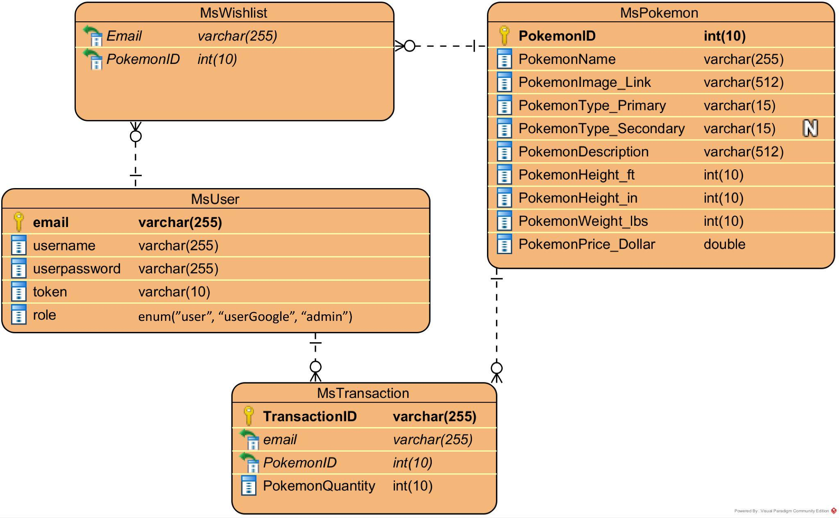

There’s also an additional helper view table called “view_ownedpokemon”. here’s the DDL:

CREATE VIEW “view_ownedpokemon” AS

AS SELECT `mt`.`Email` AS `Email`, `mu`.`token` AS `token`, `mt`.`PokemonID` AS `PokemonID`, sum(`mt`.`PokemonQuantity`) AS `OwnedPokemon` FROM (`mstransaction` `mt` join `msuser` `mu` on(`mu`.`Email` = `mt`.`Email`)) GROUP BY `mu`.`Email`, `mt`.`PokemonID`;

MAIN APP:

When the app starts to run, it will initially show a splash screen.

* Splash Screen

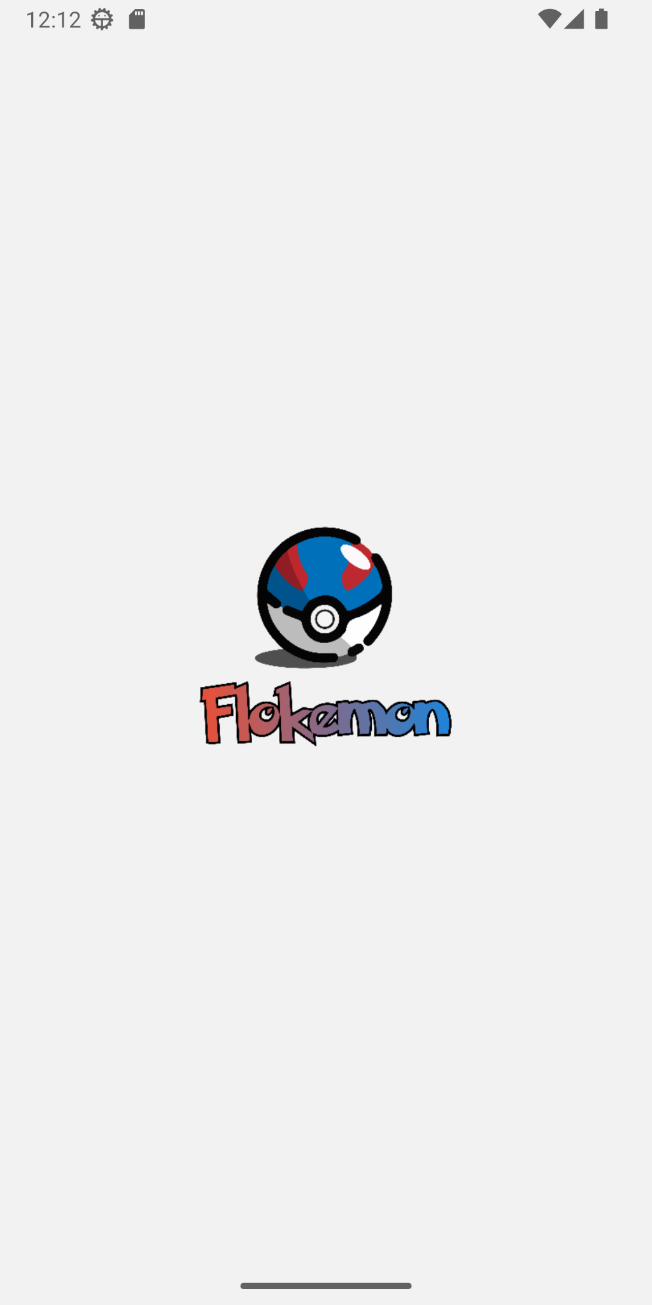

The splash screen will be displayed for 1.5 seconds, after that the app will be directed to the login page.

* Login Page  
  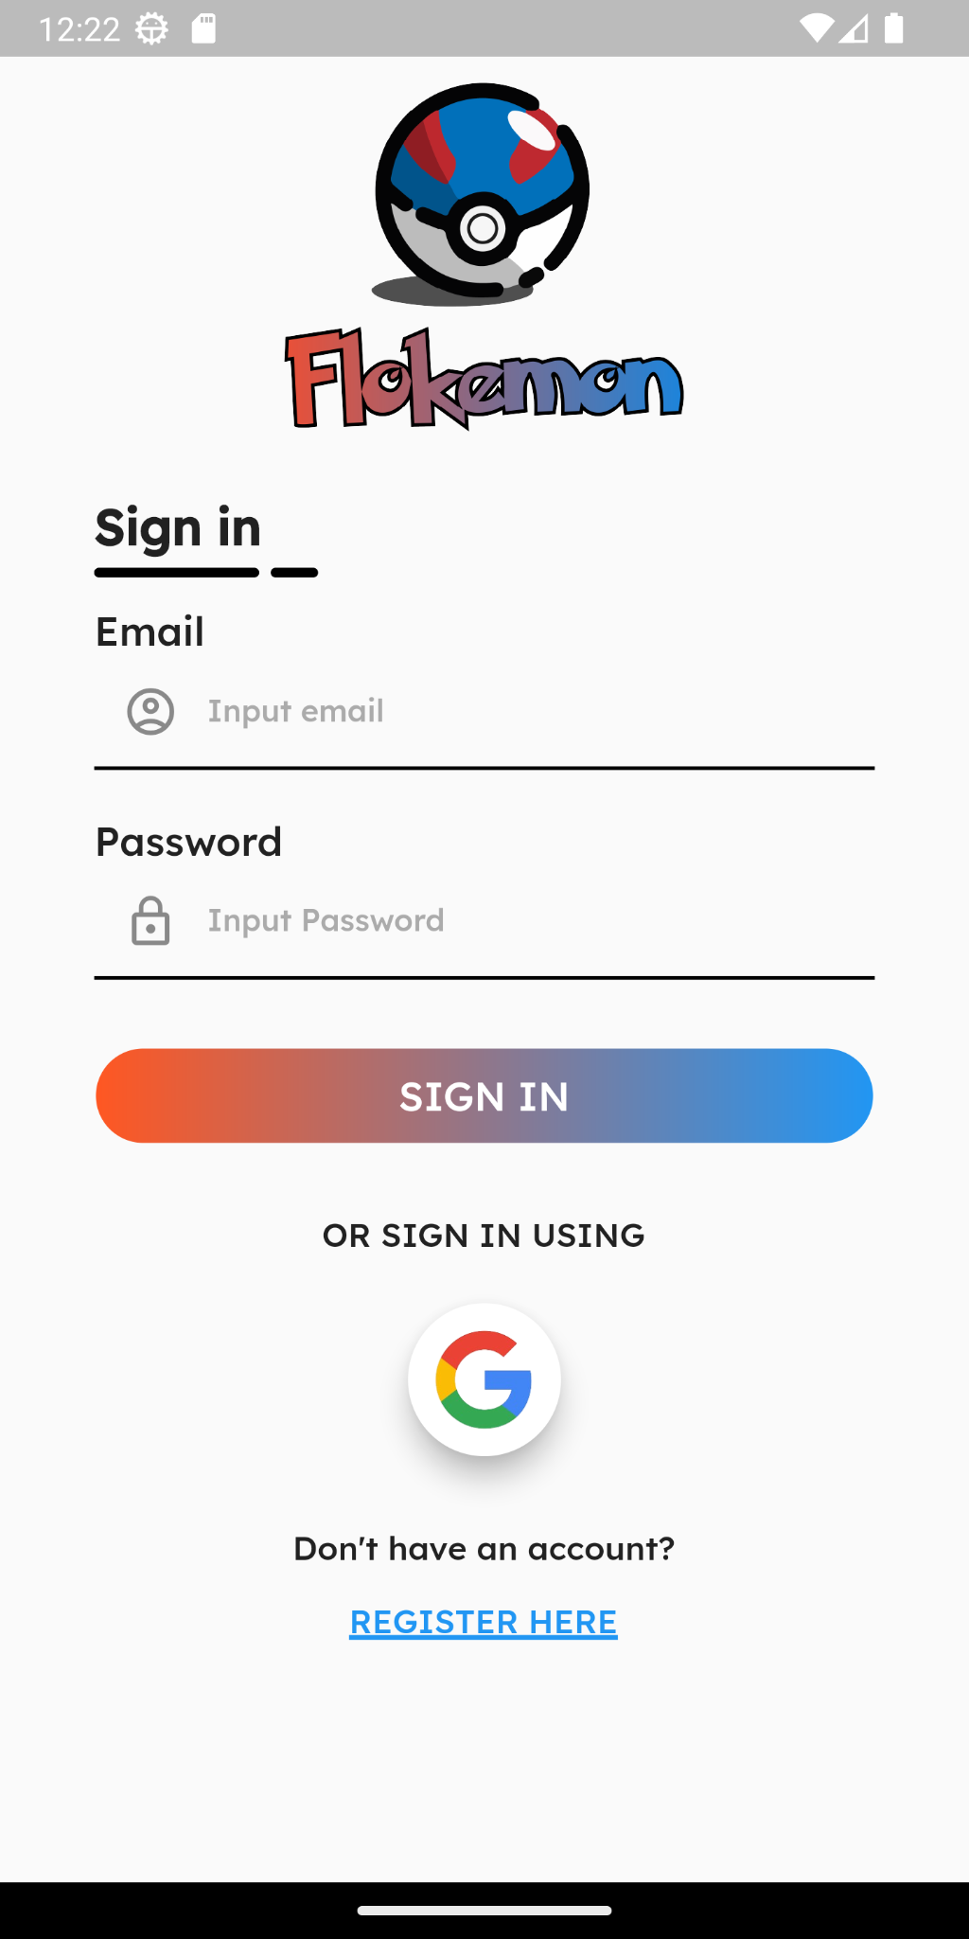
* Admin and user could use this page to log in to their respective role (user or admin)
* On this page, the user can sign in using 2 methods:
  + Using email and password field
    - The user must fill in all the email and password fields, otherwise, it will show a snack bar “All text must be filled”.
    - When the email and password were filled. it will send a request (HTTP POST) to the backend.
      * If the email does not exist in our DB. it will show a snack bar “email not exist”
      * If the email exists but the password is incorrect, it will show a snack bar “incorrect input”
      * if the email exists and the email and password match the account registered in the DB, the login is successful.
  + Using Google OAuth, where they login using a Google Account.
    - If for some reason the login is terminated/failed. The app will show a snack bar “Something went wrong while signing in with Google”
    - If the Login is successful, the app will send a request (HTTP POST) to the backend.
      * If the Google account’s email is already registered in the DB. it will return the data. Otherwise, it will create a new user in the DB with the role “userGoogle” and will return the user’s data to the app.
* If the user successfully logs in (either by DB or Google OAuth), they will be given a token generated by the backend (for the backend’s middleware purpose), and given the role of “User” (for DB user) or “userGoogle” (for Google users). And they will be directed to the home page.
* If the user doesn’t have an account or refuses to sign in using Google, they can click on the “Register here” text at the bottom of the screen which was highlighted blue to go to the register page.
* If the admin inputs the email and password with the role “admin” registered in the DB, they will be directed to the admin page.
* Register Page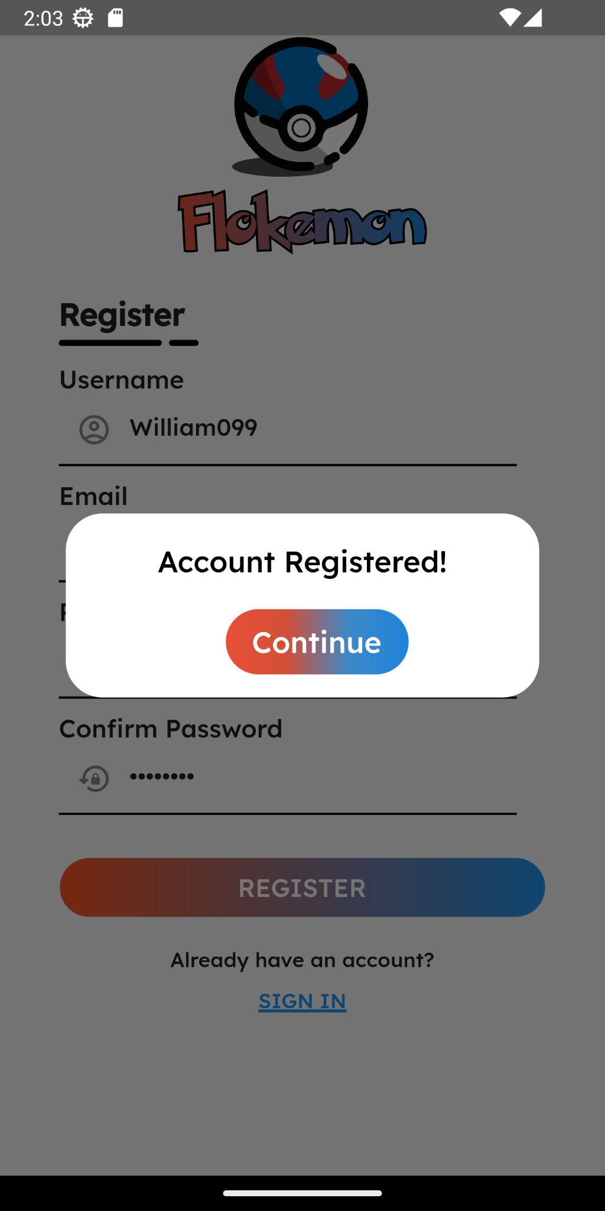

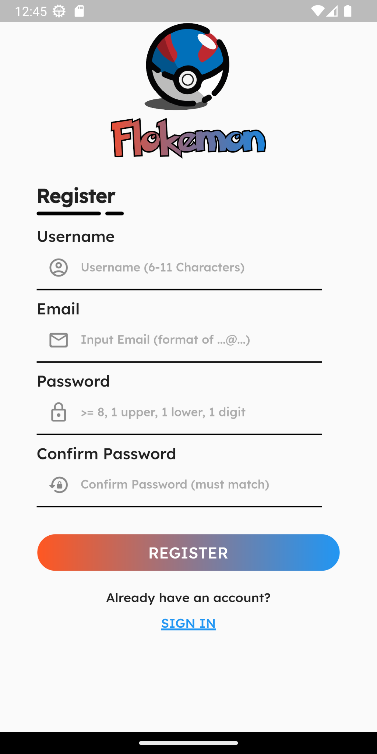

* On this page, user can register their account with the following conditions:
  + All the fields must be filled, otherwise it will show a snack bar “All fields must be filled”
  + The user name must be between 6-11 characters (inclusive). Otherwise, it will show a snack bar “username not in desired range”
  + Email must be a format of an email. Otherwise, it will show a snack bar “email format invalid!”
  + Password must be at least 8 characters long with at least 1 digit, 1 uppercase, and 1 lowercase alphabet. Otherwise, it will show a snack bar “Password not strong enough!”
  + Confirm password must be the same as the password field. Otherwise, it will show a snack bar “Confirm password not matching!”
* If the above condition was met. The app will send a request (HTTP POST) to the backend
  + If the email already exist in the DB. The app will return an error message through snack bar “email exist!”.
  + if the email does not exist in the DB. The user data will be inserted to the backend via backend.
* If the register is successful, the app will show an alert dialog “account registered” along with a “continue” button which will direct the user to the login page whenever pressed.
* If the user decides to not register, they can go back to the login page using the bottom highlighted blue text “SIGN IN”
* Home Page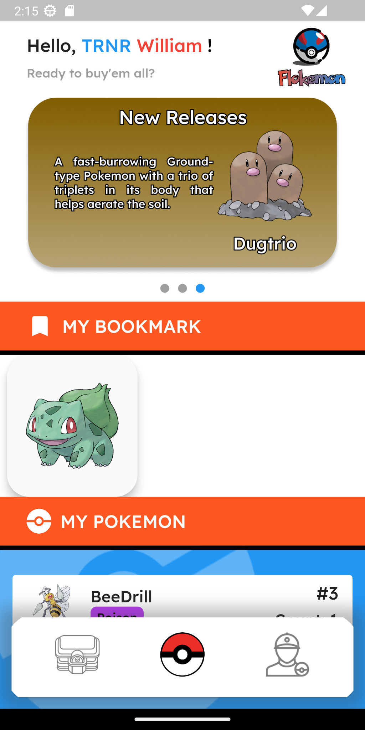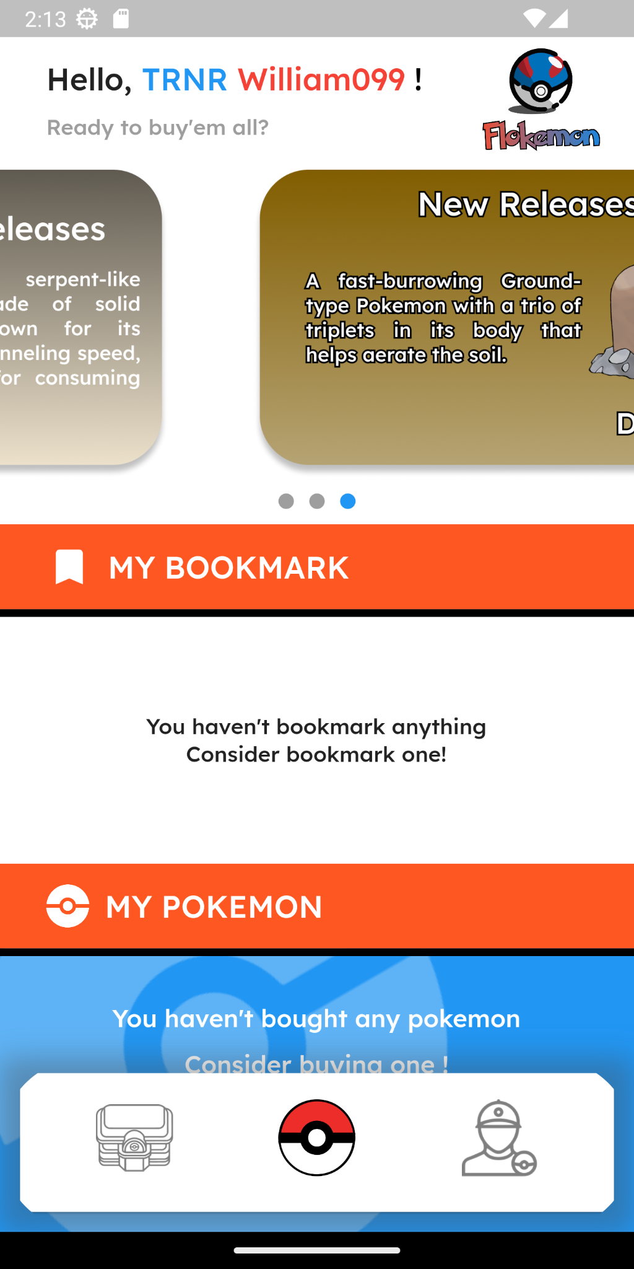

The user will be directed to this page if the login is successful, and they logged in with the role of either “user” or “userGoogle”. The user could also go to this page if they press the middle icon in the bottom navbar.

* After being directed to the home page, the app will instantly get all the necessary data needed through multiple requests (HTTP GET) to the backend:
  + Fetch All Pokemon
  + Fetch user’s transaction
  + Fetch user’s ownedPokemon
  + Fetch user’s wishlist
* NOTE: The fetched data will be passed through all the related pages to reduce the amount of calls to the backend.
* The Home Page shows:
  + The user’s username
  + The app’s logo
  + Image carousel
  + Wishlist/Bookmark (Fetched from wishlist DB)
    - If there’s no Wishlist, it will show a text “You haven’t bookmarked anything, Consider bookmark one!”
    - If the user has a wishlist, the wishlist section will showcase the Pokemon’s image. If one of the Pokemon list is pressed, it will be directed to the Pokemon detail page.
  + My Pokemon (Fetch from OwnedPokemon in the DB)
    - If the user has no Pokemon, it will show the text “You haven’t bought any Pokemon, consider buying one!”.
    - If the user has a Pokemon, the My Pokemon section will showcase the Pokemon’s image, Pokemon’s Name, Pokemon’s primary type, Pokemon’s Secondary type (if there’s one), Pokemon’s index/ID, and Pokemon’s owned Pokemon Count.
* Store Page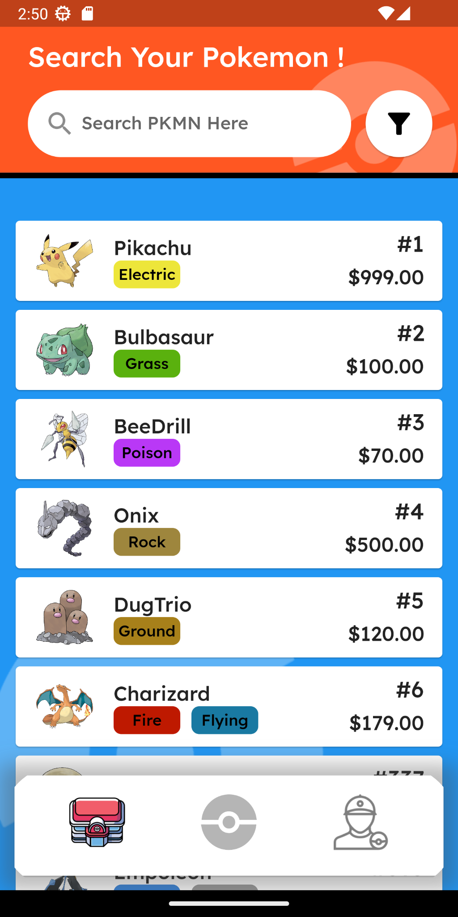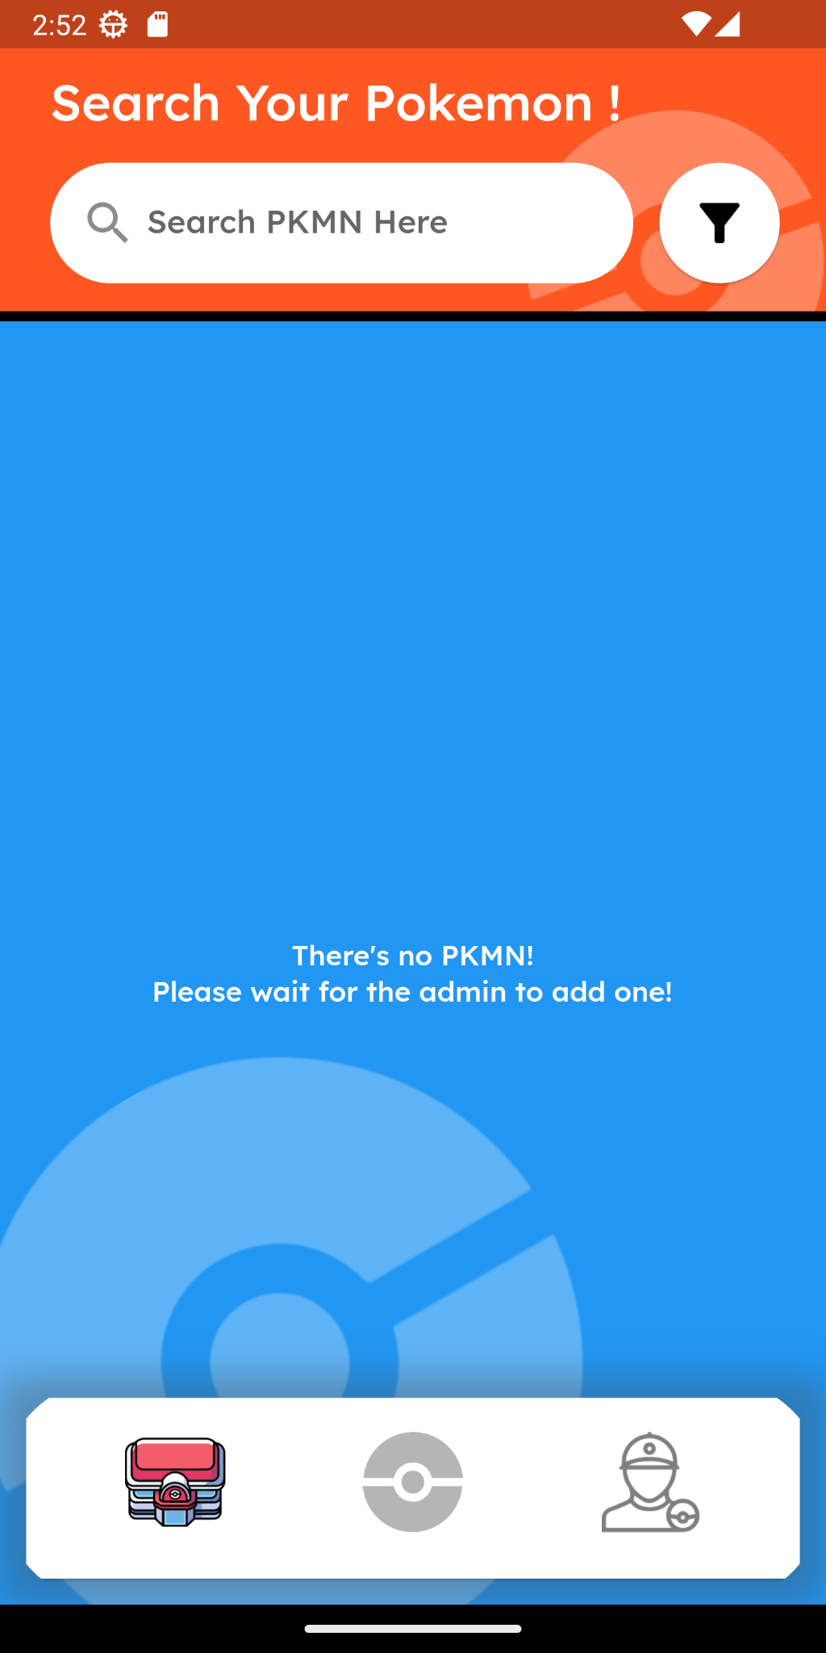

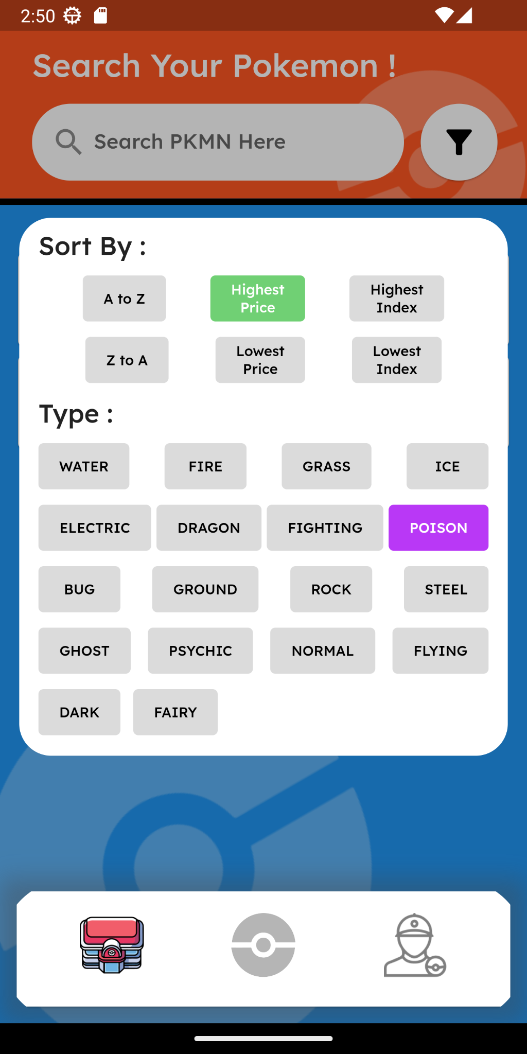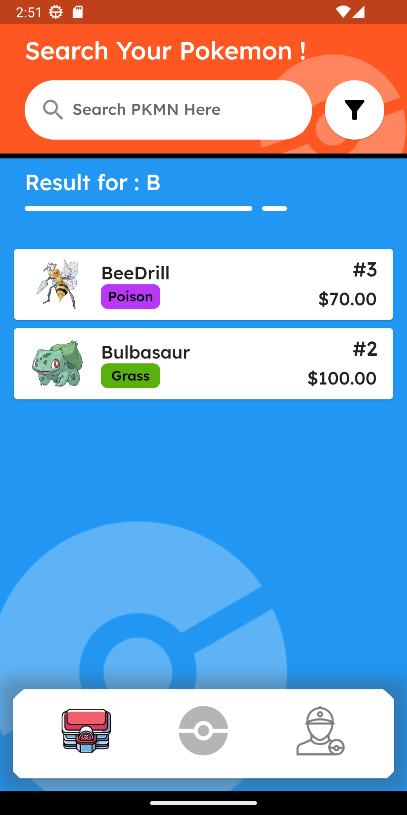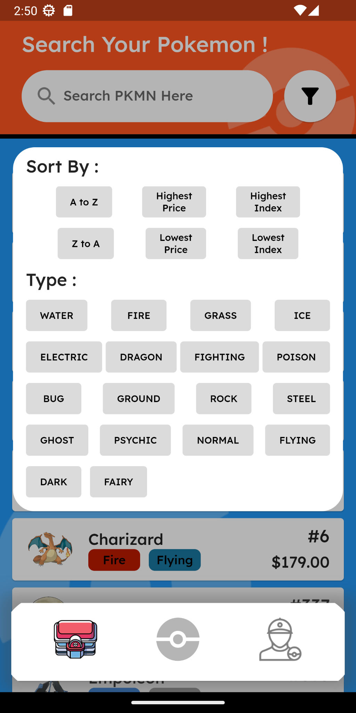

The user can go to this page if they press the left icon in the bottom navbar.

* This page shows:
  + The search bar
    - The user can type the desired Pokemon to be searched, there are 2 ways of searching:
      * If the user types a number, it will search by the Pokemon’s index/ID
      * If the user types a string/text, it will search by the Pokemon’s starting name (case insensitive)
  + The filter button
    - If the user taps the filter button, it will show a pop-up filter where the user could filter based on 2 methods:
      * The user can sort based on these 6 parameters (they can only choose 1 at a time):
        + By the Pokemon’s Name (Ascendingly or Descendingly)
        + By the Pokemon’s Price (Highest or Lowest)
        + By the Pokemon’s index (Highest to Lowest)
      * The user can filter by the corresponding 18 Pokemon type (the can only choose 1 at a time)
  + The list of pokemon
    - If there is no pokemon at all, the app will show the text “There’s no PKMN Please wait for the admin to add one!”
    - If there’s a pokemon, it will show a list where each list shows a Pokemon’s image, Pokemon’s Name, Pokemon’s Primary type, Pokemon’s Secondary type (if there’s one), Pokemon Index/ID, and Pokemon’s Price.
  + If the user presses one of the Pokemon list, the user will be directed to Pokemon detail page.

* Pokemon Detail Page

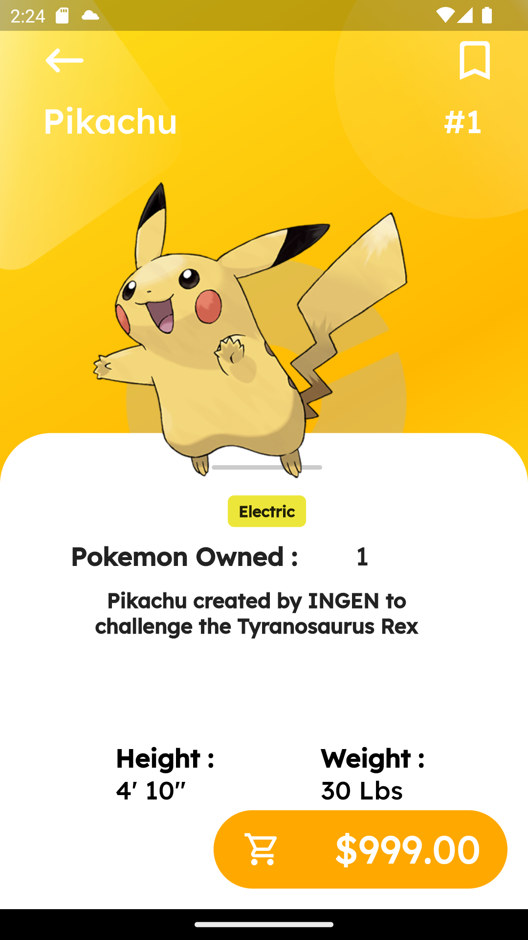

* + In this page, it shows the details of a certain Pokemon where the user has the option to just check the Pokemon’s details before buying or just checking the Pokemon’s details.
    - In this page, it consists:
      * Back button, which will lead back to the users back where they press the Pokemon from (If the user pressed the Pokemon from its inventory, it’ll go back to the Home Page, and if the user pressed the Pokemon from the store, it’ll go back to the Store Page)
      * Bookmark button, which will bookmark the Pokemon’s based on the user’s choice
      * Linear Gradient Background, which will change based on the primary type of the Pokemon, for example:



Pikachu’s primary type is Electric, so the background will be followed by the yellowish-lightning-gradient background color.

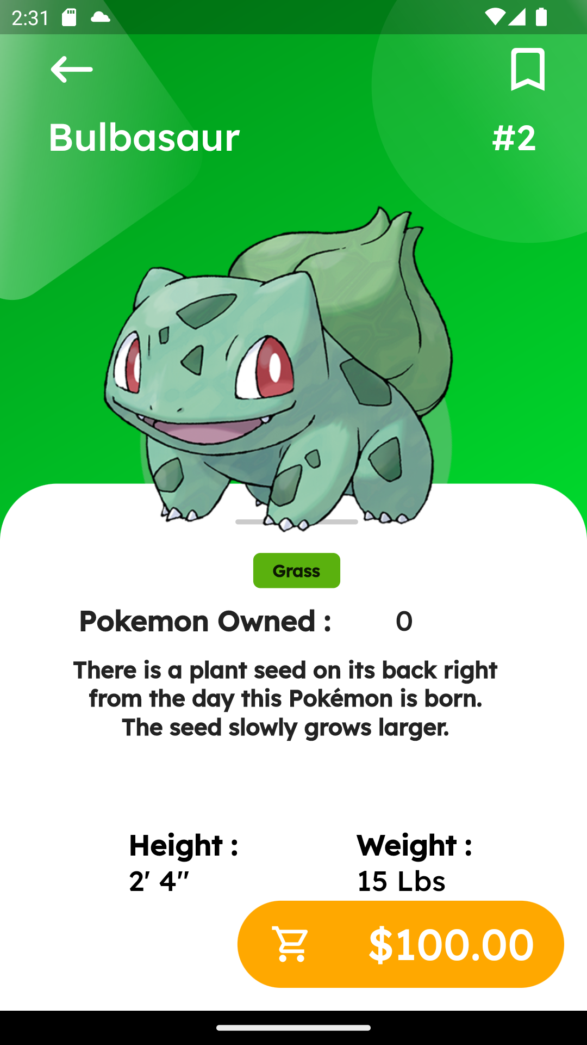

Bulbasaur’s primary type is Grass, so the background color will be followed by the greenish-grass-gradient background color.

* + - * Pokemon’s details:
        + Pokemon’s Name
        + Pokemon’s ID
        + Pokemon’s Icon
        + Pokemon’s Type
        + Owned Pokemon
        + Pokemon’s Description
        + Pokemon’s Height
        + Pokemon’s Weight
      * And the buy button, which contains the cart icon with a price beside it, pressing it will leads the user to the Bottom Sheet named “Purchase Confirmation”

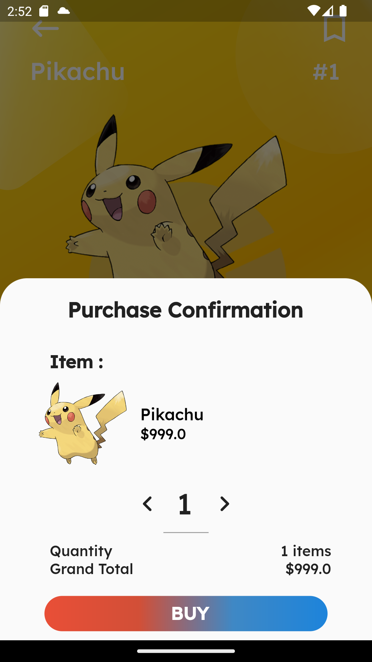

The background will darkened, if this popped up, and inside the bottom sheet consists:

* + - * + Purchase Confirmation’s Text
        + Item
        + Pokemon’s choice
        + Quantity text field
        + Quantity with total item(s)
        + Grand Total with totaled price(s)
        + Buy button, which will lead the users to an alert dialog which will confirm the user’s transaction

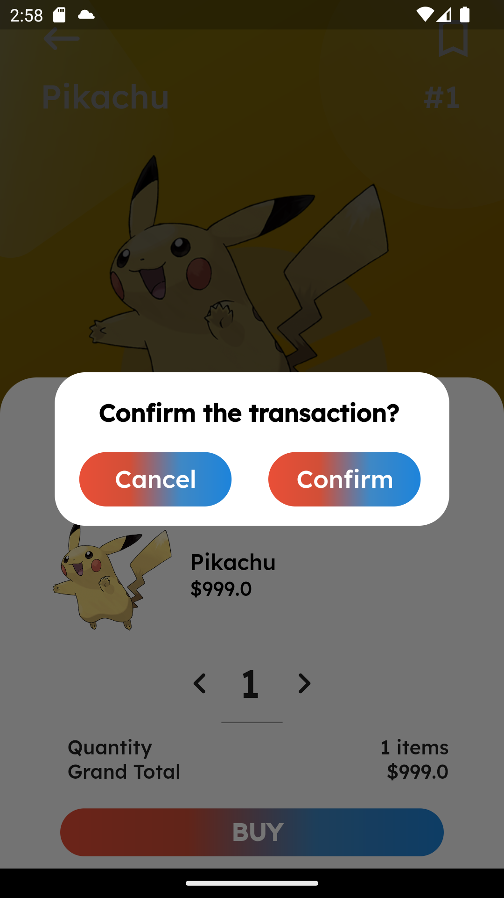

* + - * The background will be more darkened, and will show this alert dialog:
        + “Confirm the transaction?” text,
        + Cancel Button, which will pop the alert dialog and will go back to the purchase confirmation bottom sheet,
        + Confirm Button, which will pop both the alert dialog and the bottom sheet, and will bring back to the pokemon’s detail main page

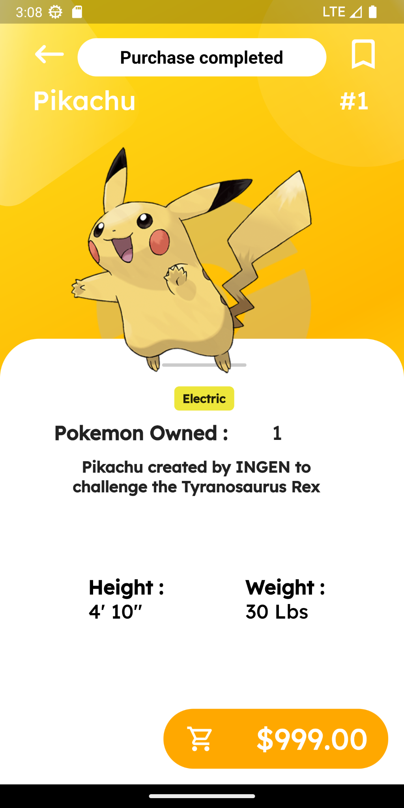

* + - * + After the user confirms the purchase, the “Purchase completed” snackbar will pop up from the top of the screen, notifying the user that the Pokemon that the user recently purchased is completed.
* User Profile

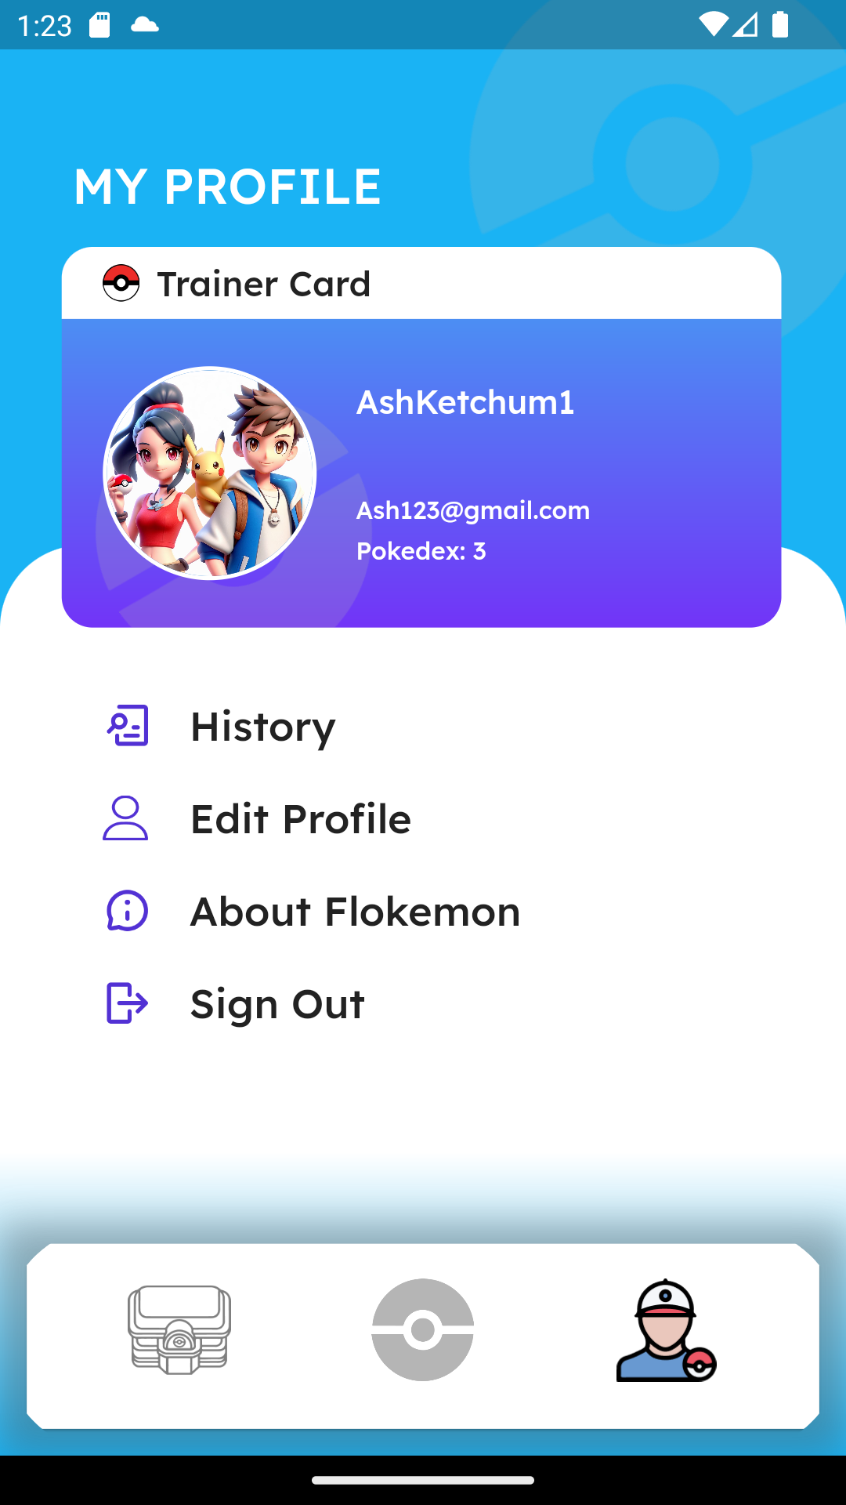

* On this page is where it shows the user’s profile, although there’s a difference in UIs where if you logged in through your own account, which requires your registered email and password, and if you logged in through your Google account.
  + This is the page if the user logged in through their own registered account



* In this User Profile page, it consists:
  + Trainer Card, which have:
    - User’s username,
    - User’s email, and
    - User’s Pokedex, which shows the amount of unique *Pokemon* user has in the inventory (Can be seen in the Home Page).
  + History, which will lead the user to the Transaction History page,
  + Edit Profile, which will lead the user to the Edit Profile page,
  + About Flokemon, which will lead the user to the About Pokemon page,
  + Sign out, which will bring the user to sign out its account and will lead the user back to the Login Page
* This is the page if the user logged in through Google Account

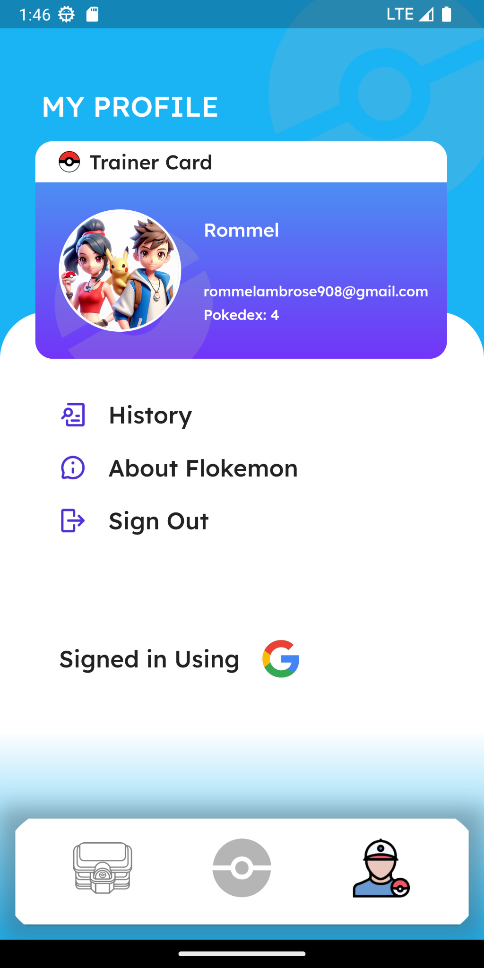

In this User Profile page, it consists:

* + Trainer Card, which have:
    - User’s username,
    - User’s email, and
    - User’s Pokedex, which shows the amount of *Pokemon* the user has in the inventory (Can be seen in the Home Page).
  + History, which will lead the user to the Transaction History page,
  + About Flokemon, which will lead the user to the About Pokemon page,
  + Sign out, which will bring an alert dialog which consist a logout confirmation that is:

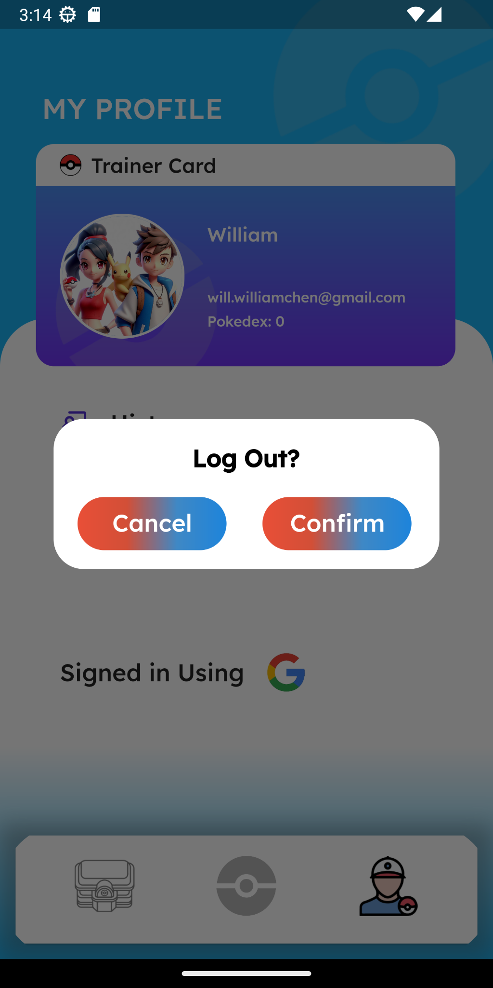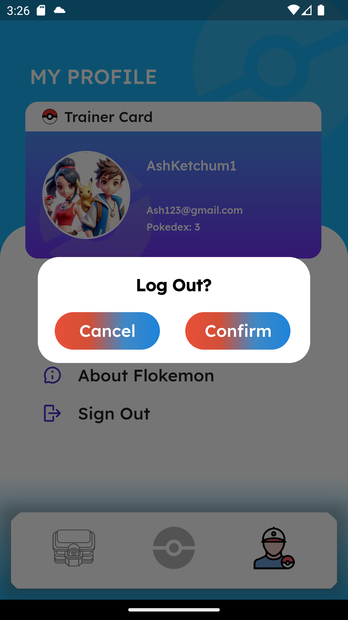

* + - A log out text
    - Cancel button, which will pop the alert dialog and return back to the user’s profile page,
    - Confirm button, which will lead back the user to the login page with 2 different snackbar pop up:
      * Signed out from Google

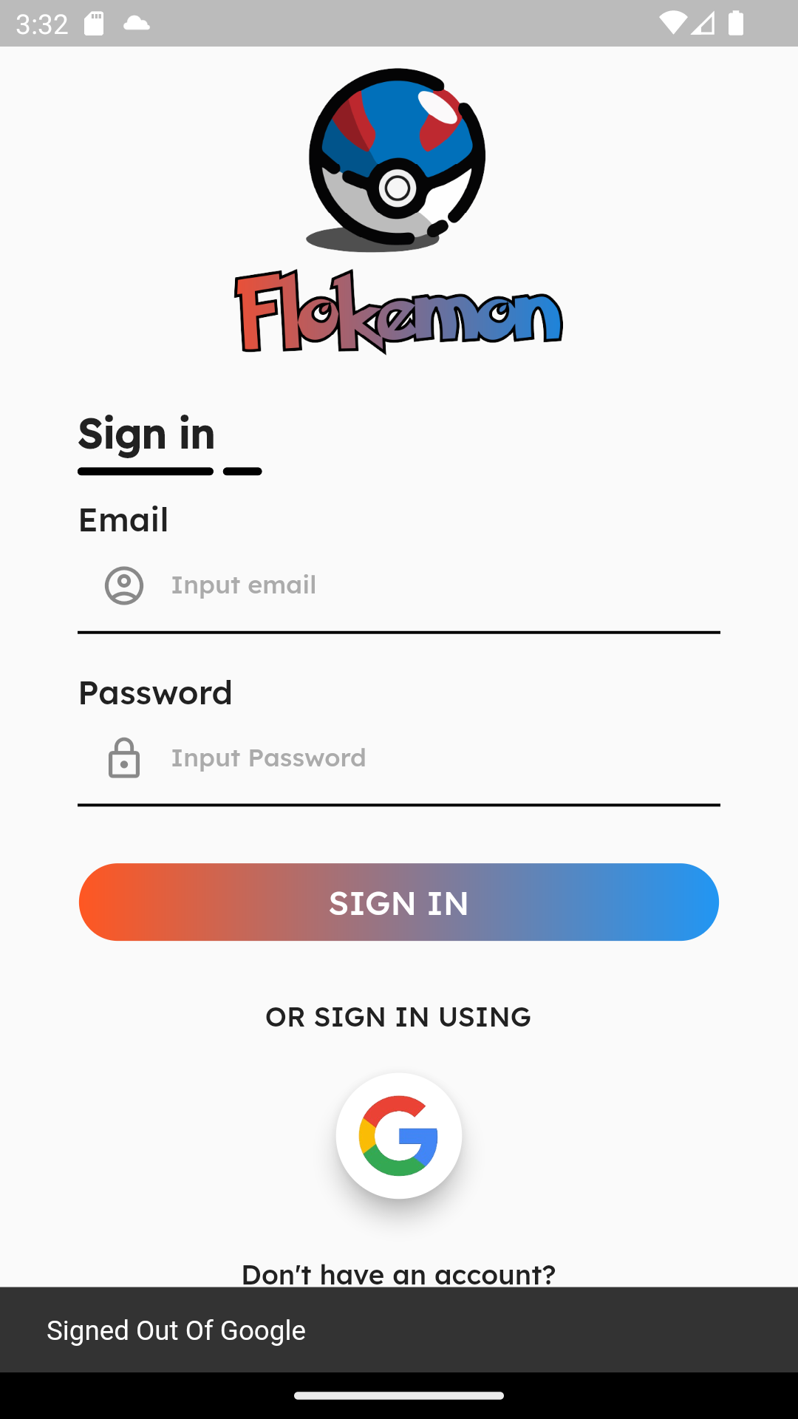

* + - * Signed out from registered account

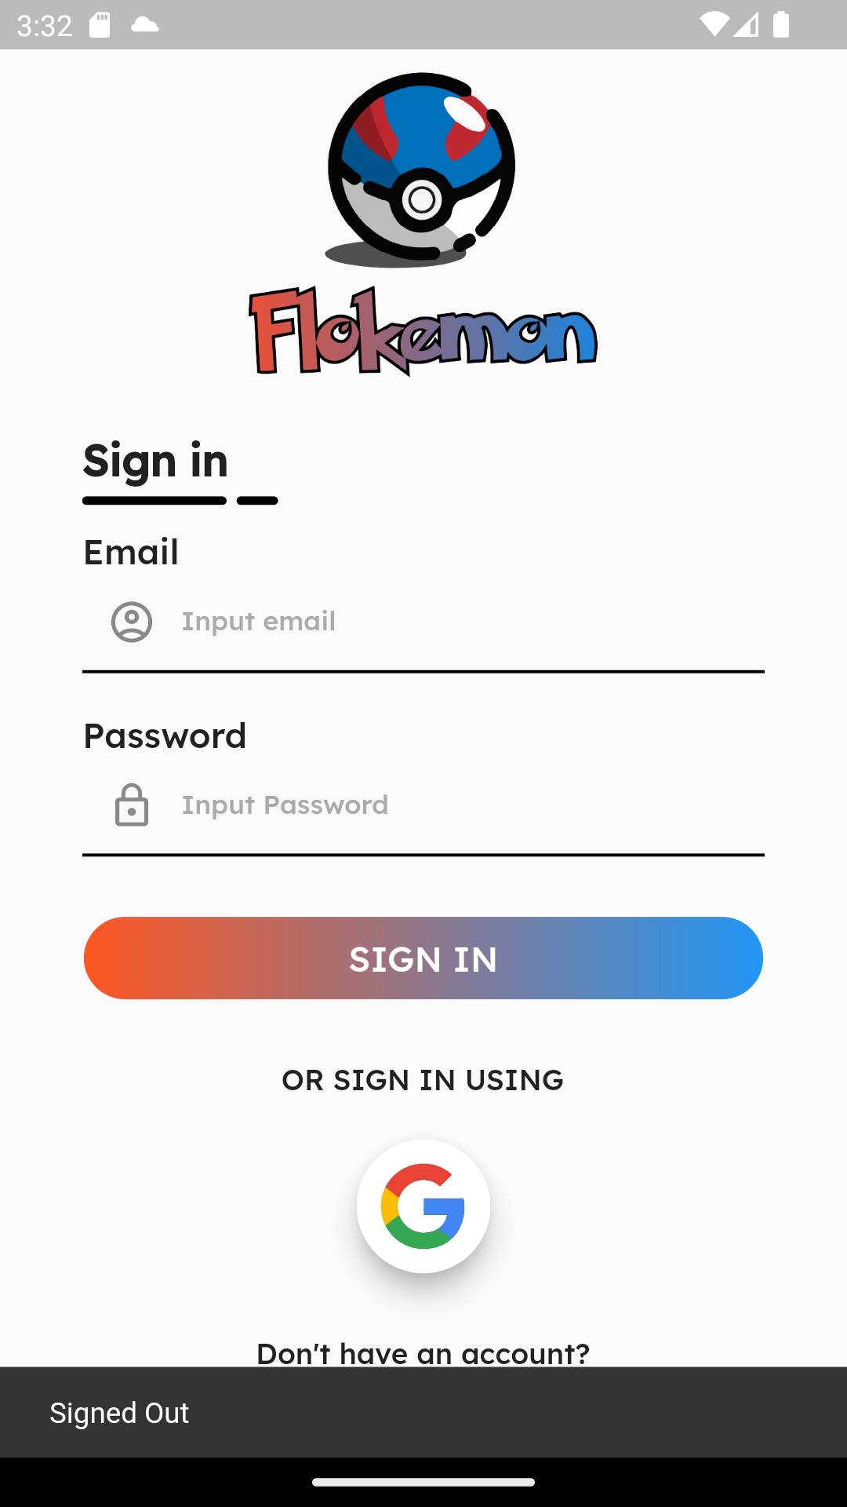

* + - Both of them have a different snackbar pop up, one with a Google account and one with a registered account. For the user’s registered account, the snackbar pop up text, which consists: “Signed Out”, while the one with Google account have a different snackbar pop up text, which consist: “Signed Out of Google”
* And above the navigator buttons, there’s a “Signed in using Google” text, which shows that the account that the user’s using at that moment is through Google, and also the reason why there’s no Edit Profile button, unlike the page where the user’s logged in through their registered account, is because after user logged in through Google, user can’t change any part of the user profile.
* Edit Profile Page

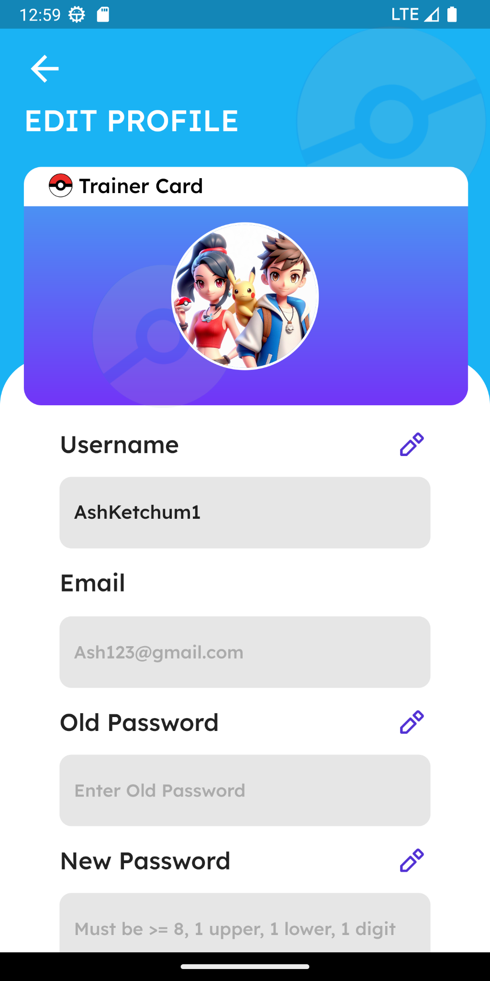 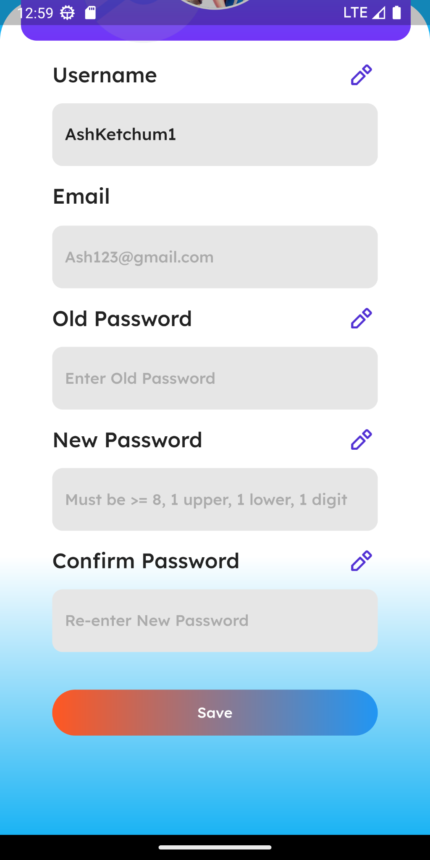

* On this page user is able to personalized their profile
  + User is able to update their username by tapping the pencil button and update their username and the username must be already prefilled
    - If the username length is less than or equal to 5 characters then it will show a snackbar “Username too short!”
    - if the username length is more than 11 characters then it will show a snackbar “Username too long!”
    - if the username length is empty and the old password is empty then it will show a snackbar “All field must be filled!”
  + User is able to update their password by tapping the pencil button and fill their old password, new password, and confirm password
    - if the old password is empty then it will show a snackbar “All field must be filled!”
    - if the new password is not empty
      * The new password must have at least 1 capital character, 1 number and more than or equal than 8 characters
        + if the new password does not match the requirement then it will show a snackbar “Password is not strong enough!”
    - if the new password and the confirm password are not a match then it will show a snackbar “Confirm password not matching!”
  + User are not allowed to update their email and their email must be already prefilled
  + The user profile image remains fixed and cannot be altered or replaced.
  + If user pressed the “Save” button
    - It will send a request (HTTP POST) to the backend
      * if the old password not match the account then it will show a snackbar “Password incorrect”
      * if all of the requirement are fulfilled and the old password match the account then it will a show a snackbar “Profile Successfully Updated”

* About Page

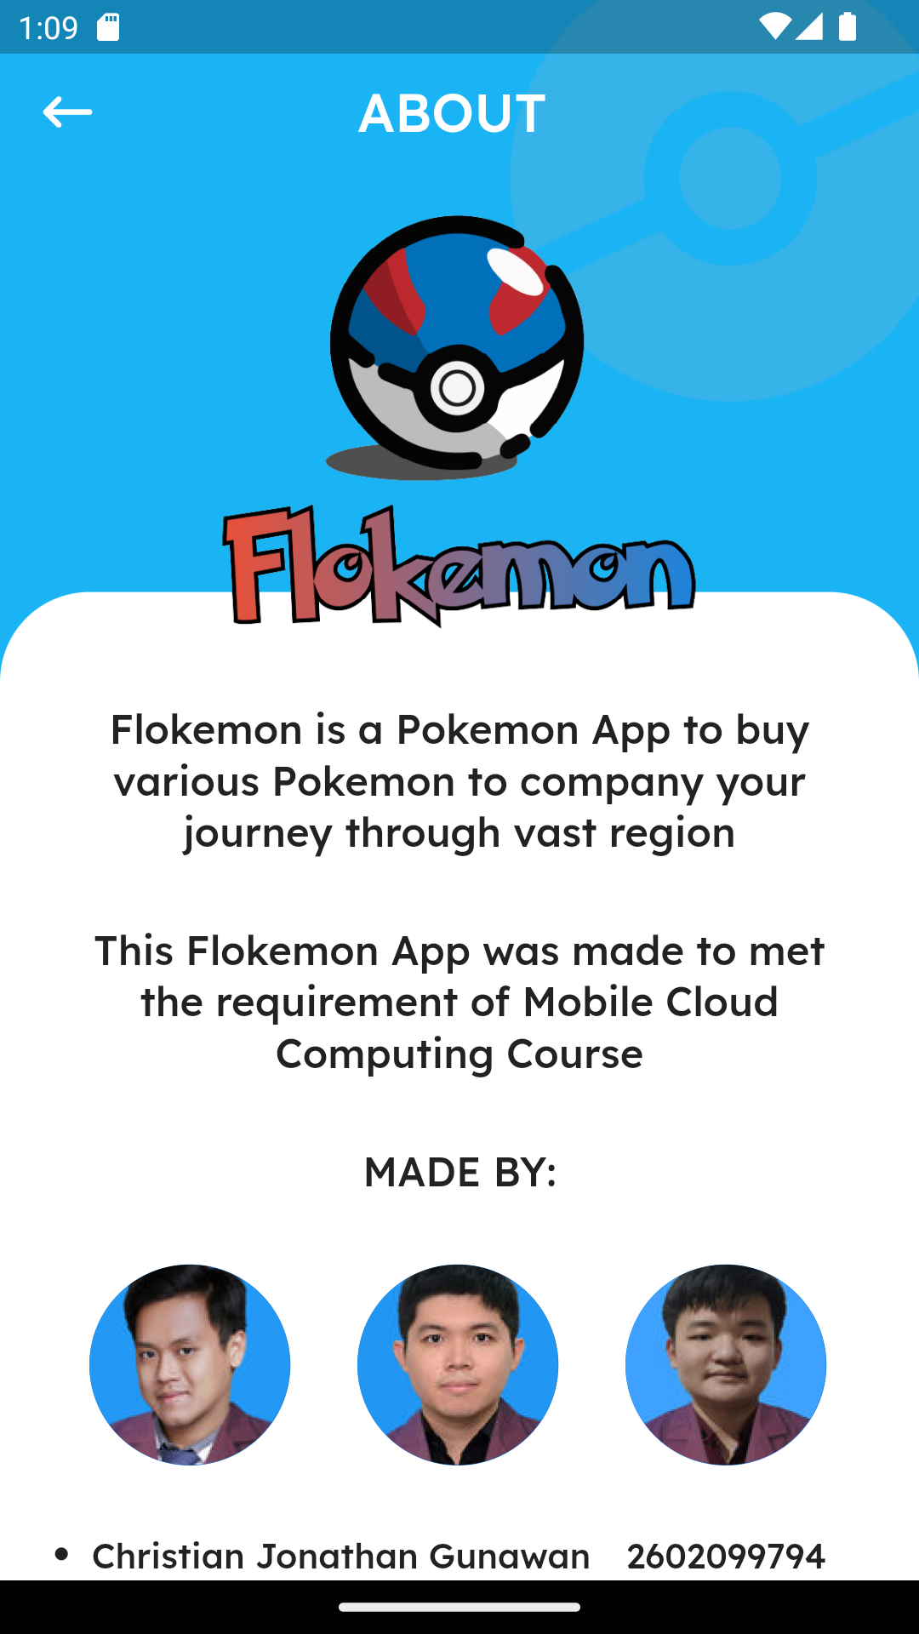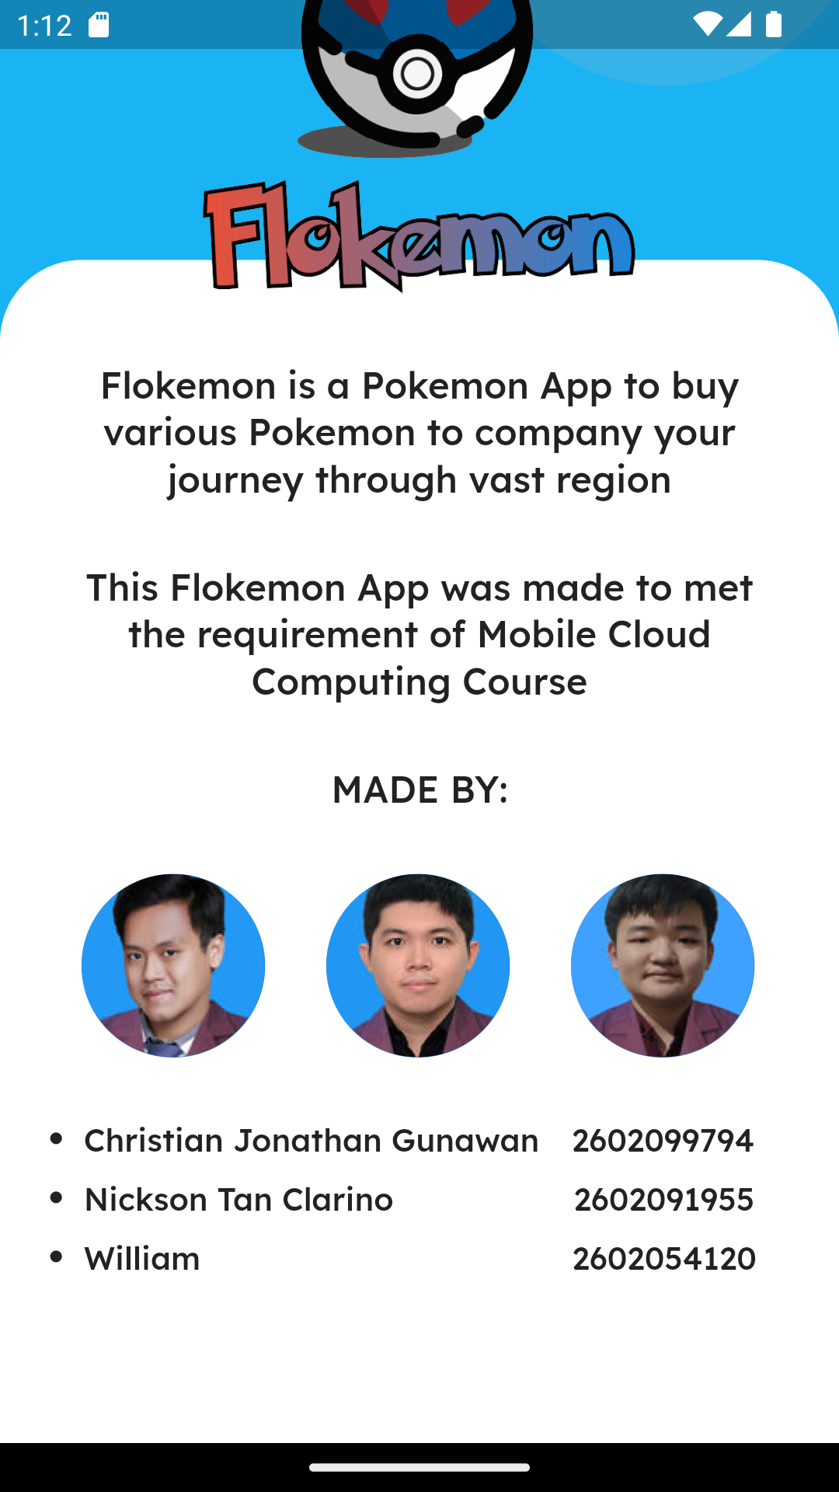

* On this page, is about this Flokemon’s app itself, it contains its logo, its description, its purpose, and the creators
  + **The description:**
    - “Flokemon is a Pokemon App to buy various Pokemon to company your journey through vast region”
  + **The purpose:**
    - “This Flokemon App was made to met the requirement of Mobile Cloud Computing Course”
  + **The creators:**
    - Cristian Jonathan Gunawan - 2602099794
    - Nickson Tan Clarino - 2602091955
    - William - 2602054120
* And there’s a back button on top left (left arrow icon), which will leads back to User Profile’s page
* History Page

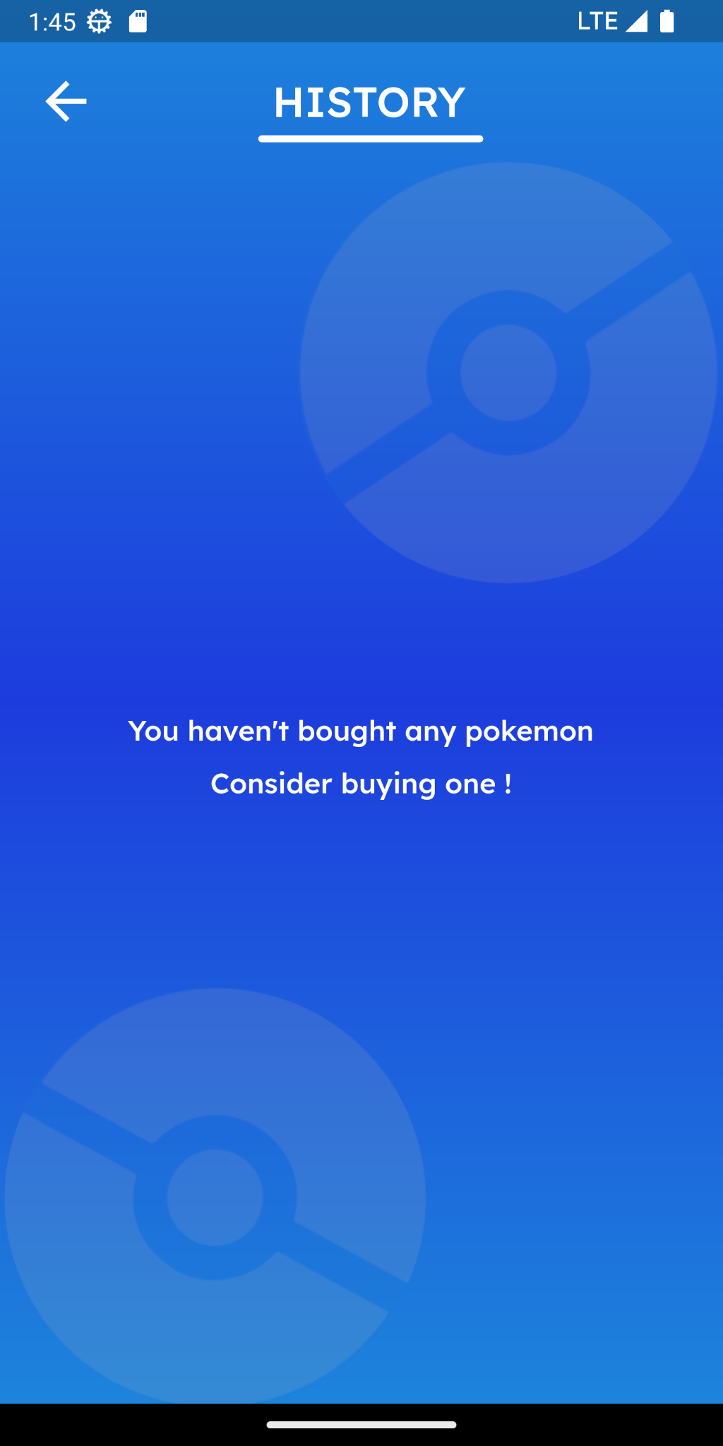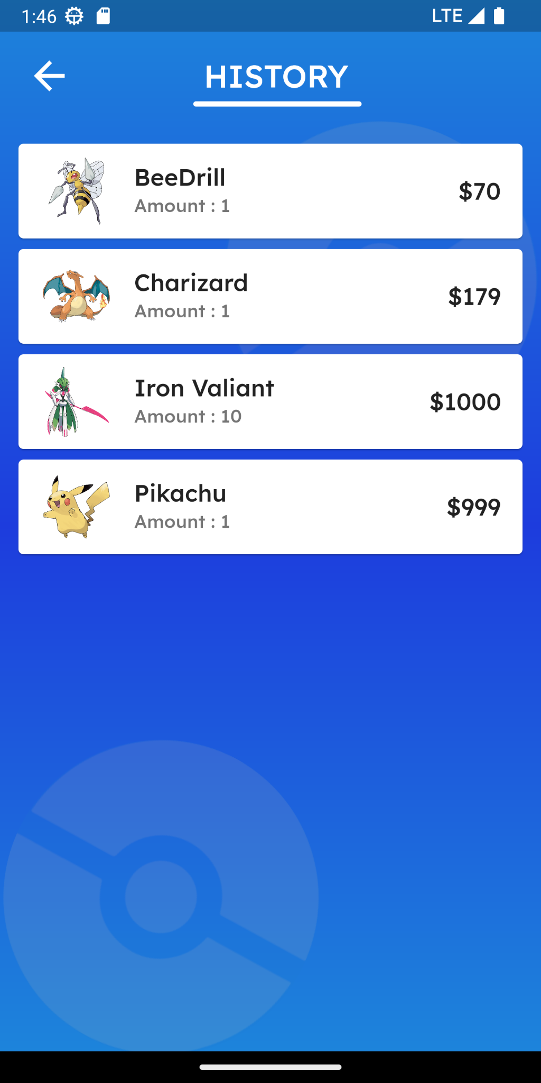

* On this page is about history transaction when the user buy the pokemon they desired and the history of the transaction detail is displayed
  + If the user doesn’t make any transaction or never buys the pokemon then it will show “You haven’t bought any pokemon” and “Consider buying one !”
  + if the user already buy the *Pokemon* then it will show the list of the transaction
    - Each transaction showcases the name of the *Pokemon*, the quantity purchased by the user, and the total price of the acquired *Pokemon*
* Admin Page

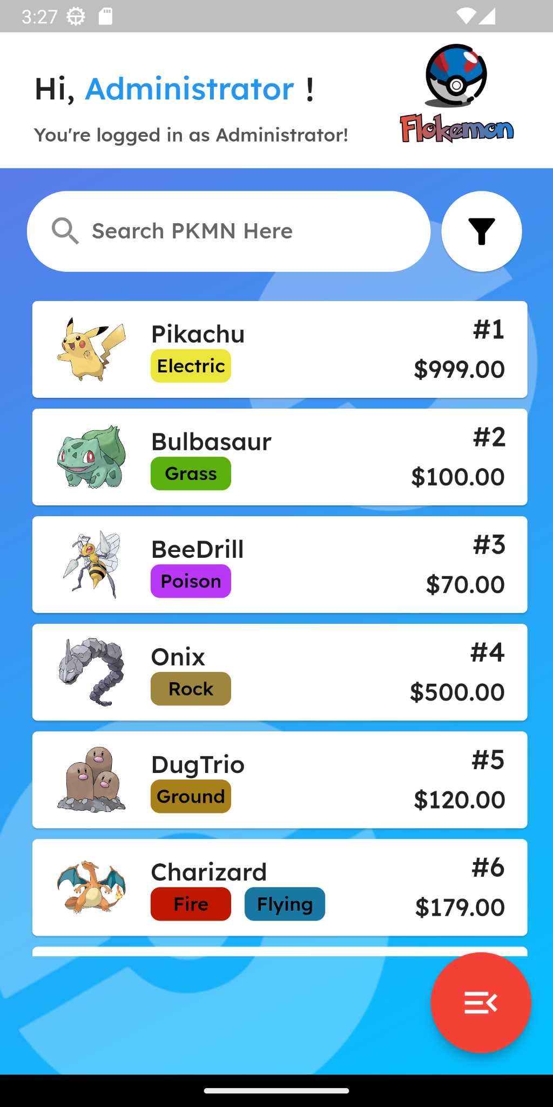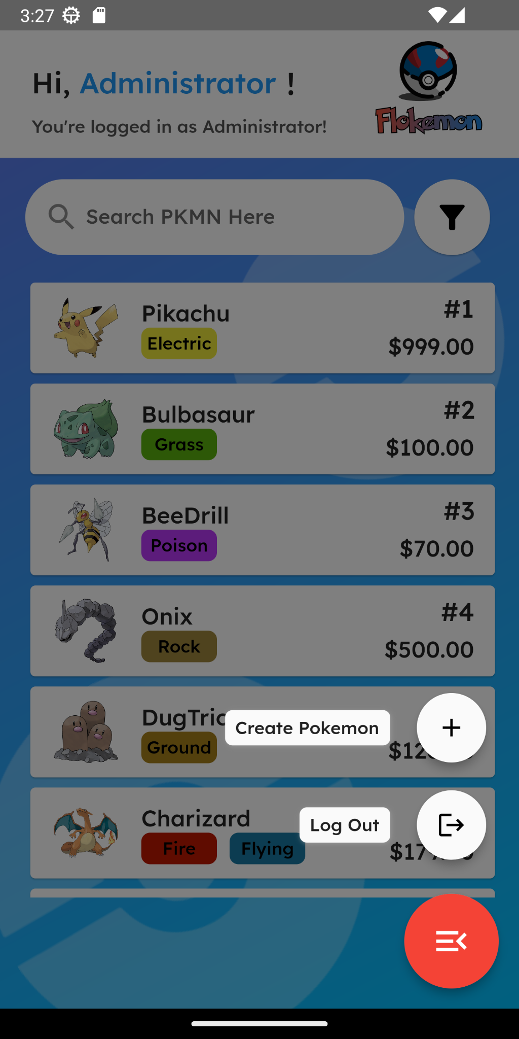

The admin will be directed to this page if the admin was successfully login under the role of “admin”.

* This page shows:
  + The search bar
    - The admin can type the desired Pokemon to be searched, there are 2 ways of searching:
      * If the admin types a number, it will search by the Pokemon’s index/ID
      * If the admin types a string/text, it will search by the Pokemon’s starting name (case insensitive)
  + The filter button
    - If the admin taps the filter button, it will show a pop-up filter where the admin could filter based on 2 methods:
      * The admin can sort based on these 6 parameters (they can only choose 1 at a time):
        + By the Pokemon’s Name (Ascendingly or Descendingly)
        + By the Pokemon’s Price (Highest or Lowest)
        + By the Pokemon’s index (Highest to Lowest)
      * The admin can filter by the corresponding 18 Pokemon type (the can only choose 1 at a time)
  + The list of pokemon
    - If there is no pokemon at all, the app will show the text “There’s no PKMN Consider adding one!!”
    - If there’s a pokemon, it will show a list where each list shows a Pokemon’s image, Pokemon’s Name, Pokemon’s Primary type, Pokemon’s Secondary type (if there’s one), Pokemon Index/ID, and Pokemon’s Price.
  + If the admin presses one of the Pokemon list, the user will be directed to the admin’s Pokemon detail page.
  + Floating Action button
    - When pressed, the button will show 2 child buttons.
      * The create Pokemon button. If pressed, the app will be directed to the Create Pokemon page.
      * The log out button. If pressed, the admin will be directed to the login Page.
* Create Pokemon Page

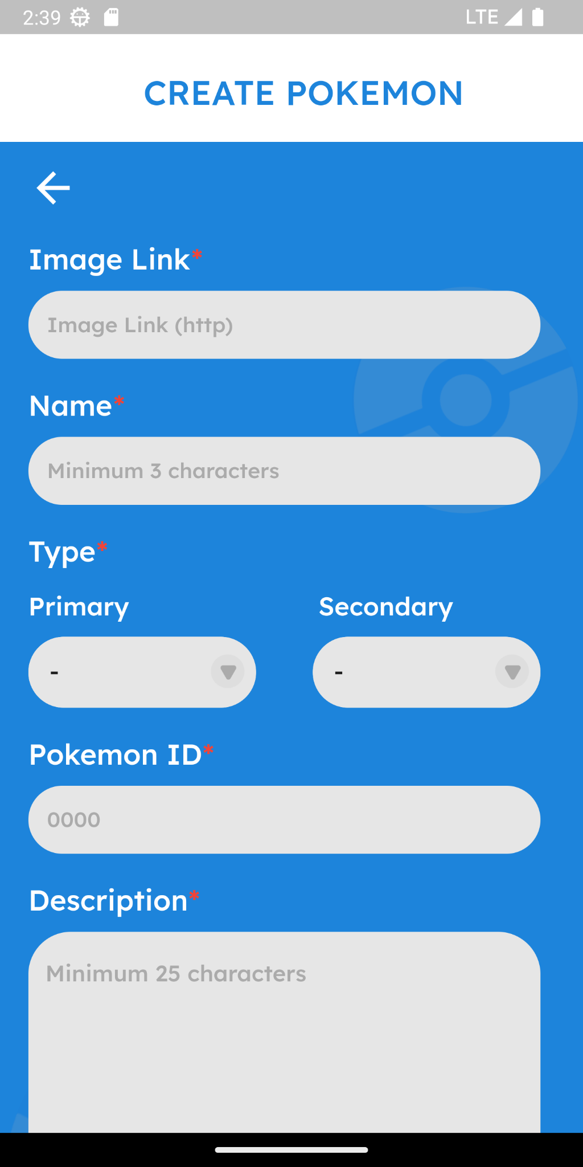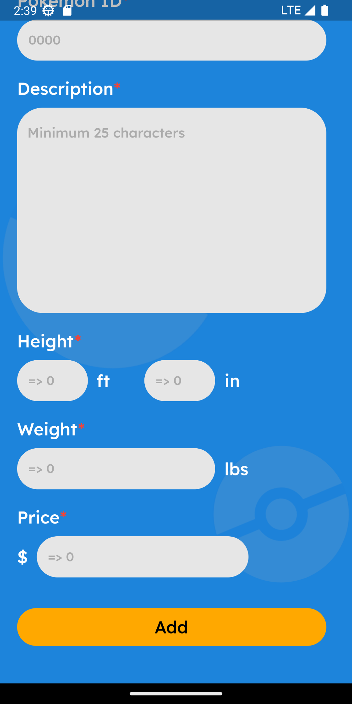

This is the page where the admin create the pokemon

* + All the field on this page except Type Secondary must be filled otherwise it will show a snackbar “All * must be filled”
  + The requirement of each filled
    - Image Link
      * If image link is not http then it will show a snackbar “Invalid URL for Pokemon Image”
      * If image link is valid but the image is not accessible then the image will be change to the logo of the flokemon
    - Name
      * If the username length is less than or equal to 3 characters then it will show a snackbar “Minimum 3 characters for Pokemon Name”
    - Type
      * If Primary Type is empty then it will show a snackbar “Primary type must be filled”
      * If Primary Type and Secondary Type are the same then it will show a snackbar “Type cannot be the same”
      * Secondary Type is allowed to be empty
    - Pokemon ID
      * If Pokemon ID is empty or the Pokemon ID is less than or equal to 0 then it will show a snackbar “ID must be more than 0”
    - Pokemon Description
      * If the Pokemon Description is empty or the Pokemon Description is less than 25 then it will show a snackbar “Minimum 25 characters for Description”
    - Height
      * if the Height ft is empty or the Height ft is less than 0 then it will show a snackbar “Height ft must be more than 0”
      * if the Height in is empty or the Height in is less than 0 then it will show a snackbar “Height in must be more than 0”
    - Weight
      * if the Weight is empty or the Weight is less than 0 then it will show a snackbar “Weight must be more than 0”
    - Price
      * if the Price is empty or the Price is less than 0 then it will show a snackbar “Price must be more than 0”
  + If the Admin press the “Add” Button
    - It will send a request (HTTP POST) to the backend
      * if Pokemon ID already existed in the database then it will show a snackbar “ID already exist”
      * if all of the requirements are fulfilled and the Pokemon ID is unique then it will show a snackbar “Pokemon Created!”
* Pokemon Detail Admin Page

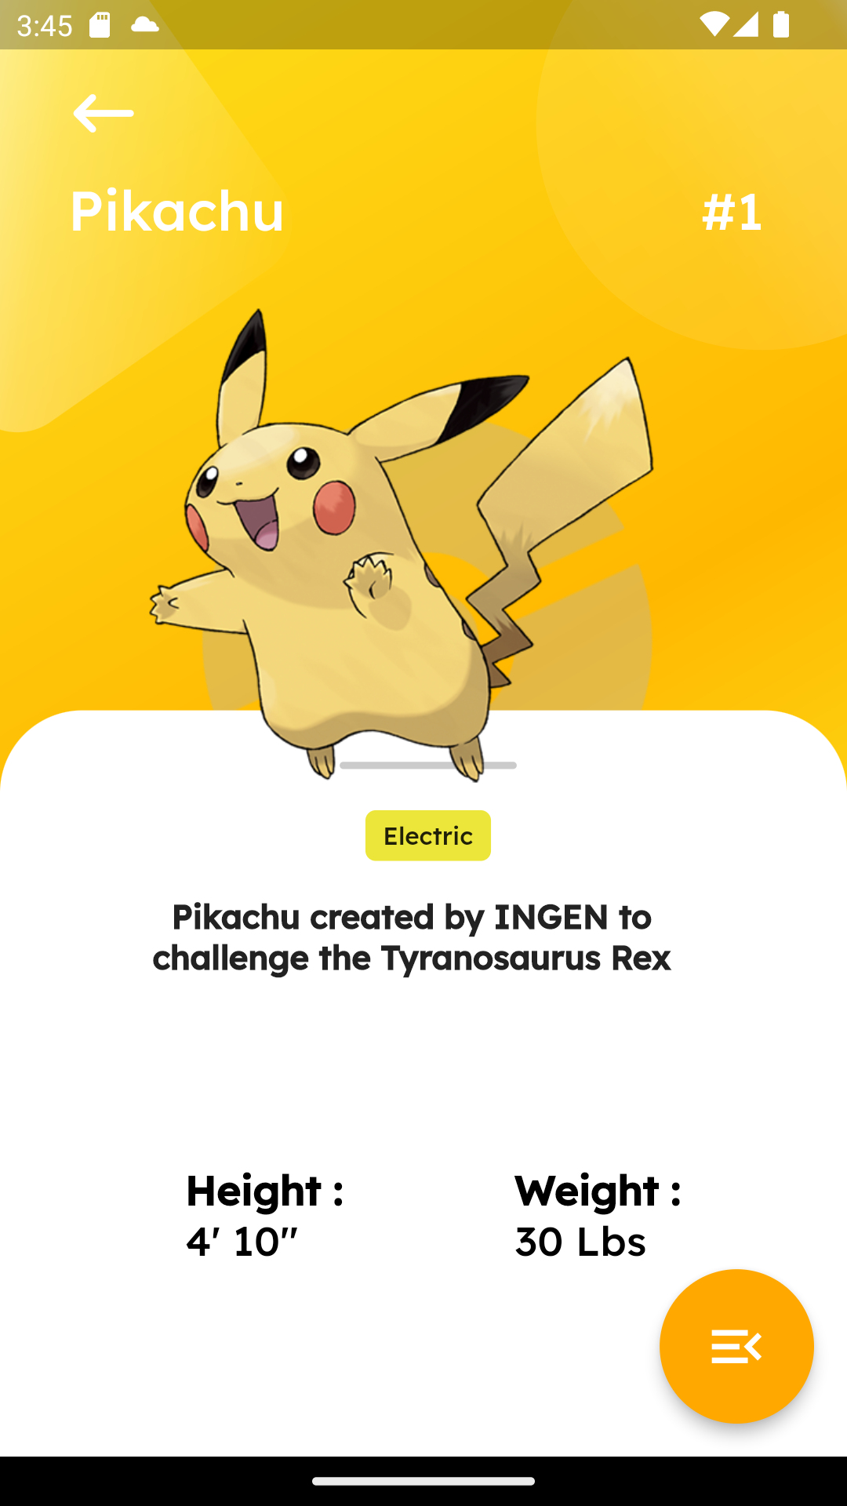

* + In this page, it shows the details of a certain Pokemon where the admin has the option to just check the Pokemon’s details or has the option to either delete or update the Pokemon’s details
    - In this page, it consists:
      * Back button, which will lead back to the Admin’s Home Page
      * Linear Gradient Background, which will change based on the primary type of the Pokemon, for example:



Pikachu’s primary type is Electric, so the background will be followed by the yellowish-lightning-gradient background color.



Bulbasaur’s primary type is Grass, so the background color will be followed by the greenish-grass-gradient background color.

* + - * Pokemon’s details:
        + Pokemon’s Name
        + Pokemon’s ID
        + Pokemon’s Icon
        + Pokemon’s Type
        + Pokemon’s Description
        + Pokemon’s Height
        + Pokemon’s Weight, and
        + The floating action button, which will darkened the background and inside of it consists:

Delete Pokemon

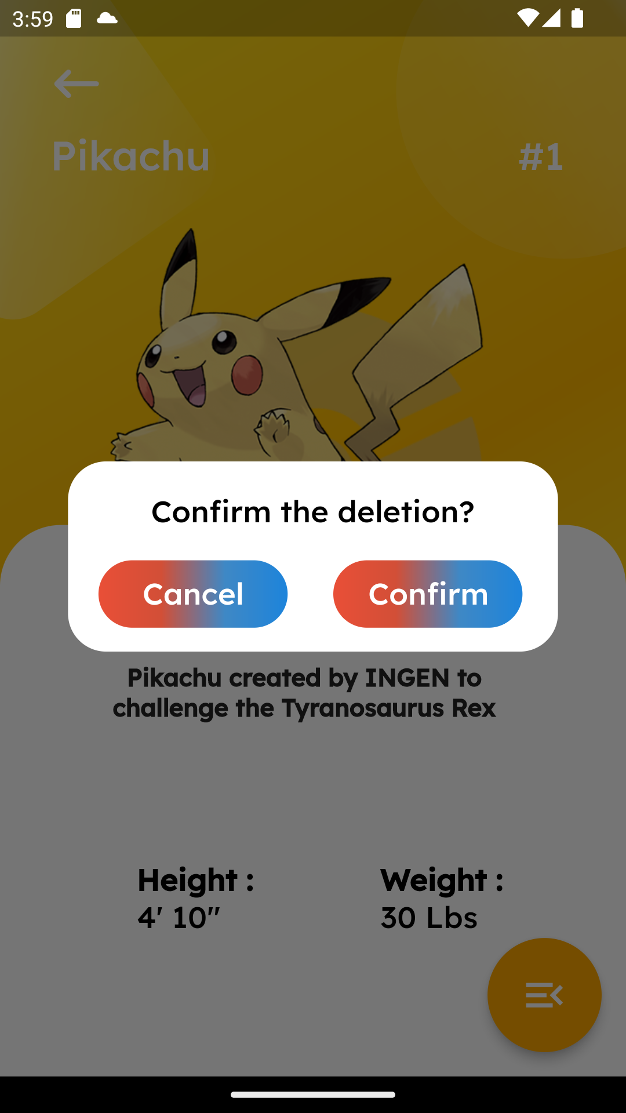

This will lead the Admin to an alert dialog, that contains:

Confirm the deletion’s text

Cancel button, which will pop the alert dialog, and return back to the Pokemon Details Admin Page

Confirm button, which will bring the Admin back to the Admin’s Home Page, whilst also showing the snackbar that appear at the bottom of the screen texted “Deletion Completed”

Update Pokemon

Which will redirect the Admin towards the Update Pokemon Page

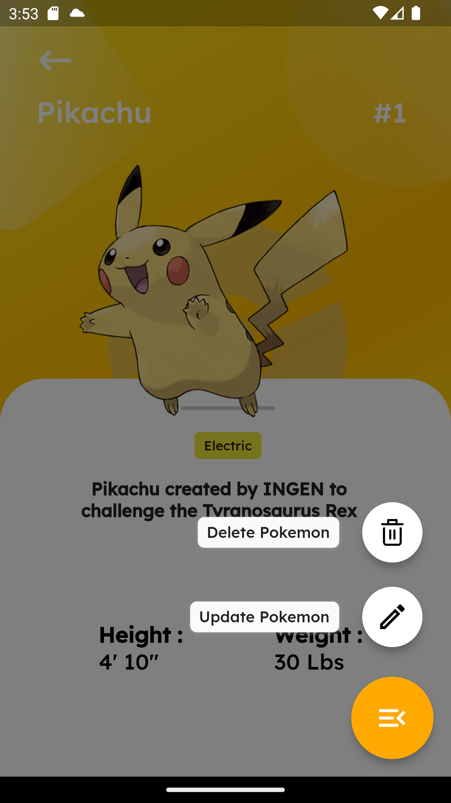

* Update Pokemon Page

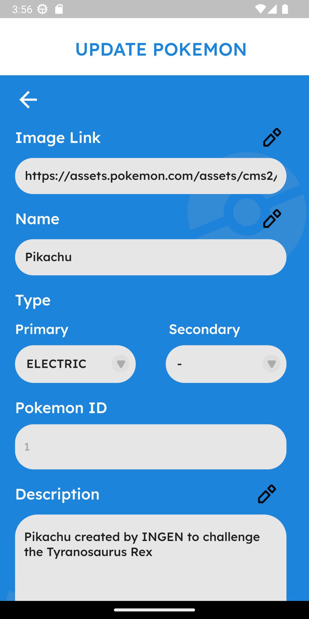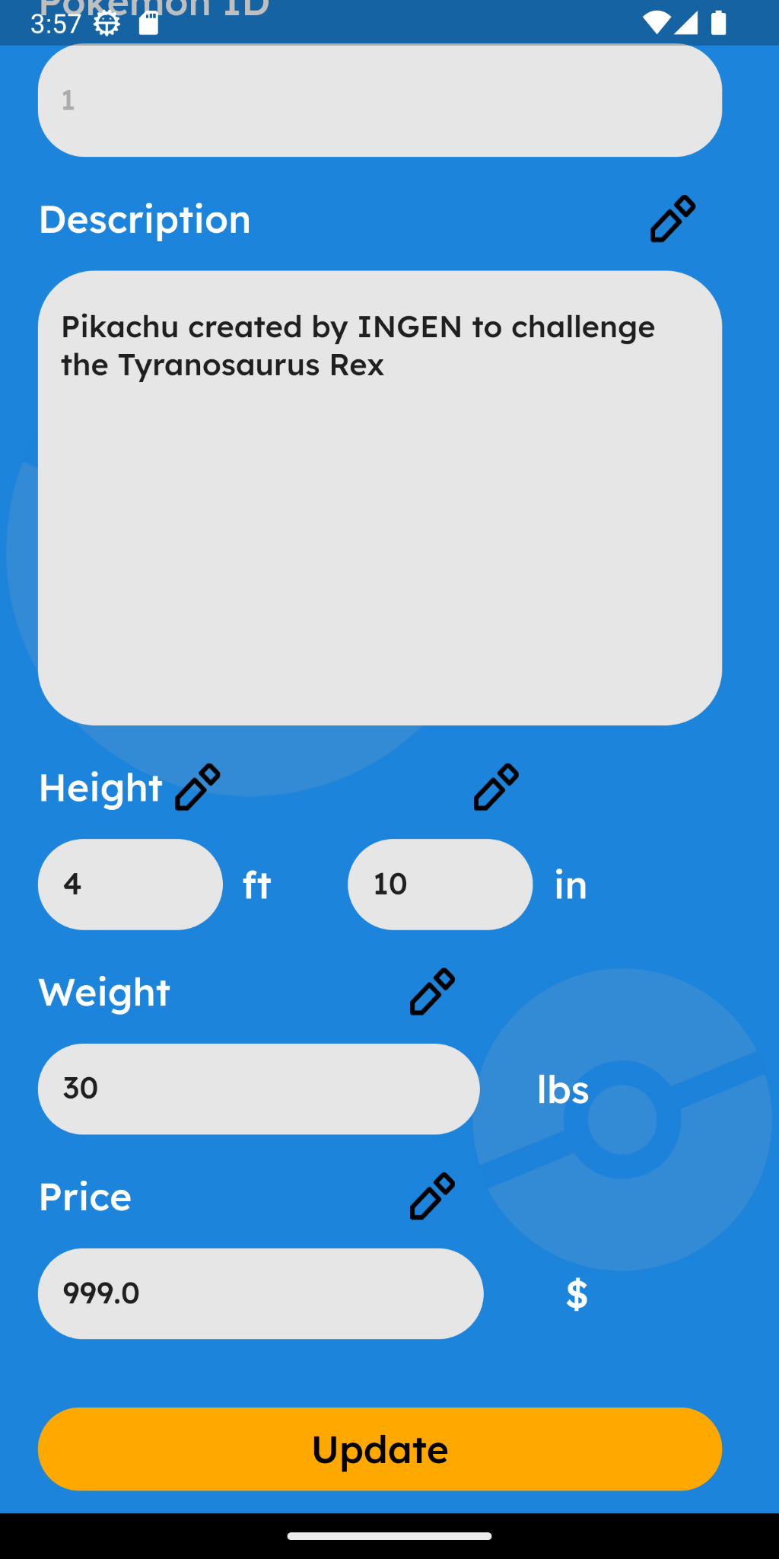

* + This is the page where admin update their Pokemon
    - Admin is able to update their *Pokemon* by tapping the pencil button
    - All the field on this page except Type Secondary must be filled otherwise it will show a snackbar “All * must be filled”
    - The requirement of each filled and all of the form must be prefilled
      * Image Link
        + If image link is not http then it will show a snackbar “Invalid URL for Pokemon Image”
        + If image link is valid but the image is not accessible then the image will be change to the logo of the flokemon
      * Name
        + If the username length is less than or equal to 3 characters then it will show a snackbar “Minimum 3 characters for Pokemon Name”
      * Type
        + If Primary Type is empty then it will show a snackbar “Primary type must be filled”
        + If Primary Type and Secondary Type are the same then it will show a snackbar “Type cannot be the same”
        + Secondary Type is allowed to be empty
      * Pokemon ID
        + Admin are not allowed to change the PokemonID
      * Pokemon Description
        + If the Pokemon Description is empty or the Pokemon Description is less than 25 then it will show a snackbar “Minimum 25 characters for Description”
      * Height
        + if the Height ft is empty or the Height ft is less than 0 then it will show a snackbar “Height ft must be more than 0”
        + if the Height in is empty or the Height in is less than 0 then it will show a snackbar “Height in must be more than 0”
      * Weight
        + if the Weight is empty or the Weight is less than 0 then it will show a snackbar “Weight must be more than 0”
      * Price
        + if the Price is empty or the Price is less than 0 then it will show a snackbar “Price must be more than 0”
  + If the Admin press the “Update” Button
    - It will send a request (HTTP POST) to the backend
      * if all of the requirements are fulfilled then it will show a snackbar “PKMN Updated!”

**Reference**

* UI Design (Figma) - View Only Link

<https://www.figma.com/file/7Vo2ziSDmkXmehEcM35kLx/MCC?type=design&mode=design>

**Group Member**

* <2602054120> – <William>
* <2602091955> – <Nickson Tan Clarino>
* <2602099794> – <Christian Jonathan Gunawan>